Empathy Phase
Empathize & Discover
Date | 14 APRIL 2025
Team ID | SWTID1742640402
Project Name | MyRide
Maximum Marks | 4 Marks

To deeply understand the needs and pain points of both passengers and drivers, we conducted user surveys, interviews, and ride-along observations. The insights were organized into an Empathy Map Canvas, revealing key behavioral and emotional patterns.

Passenger Empathy Map

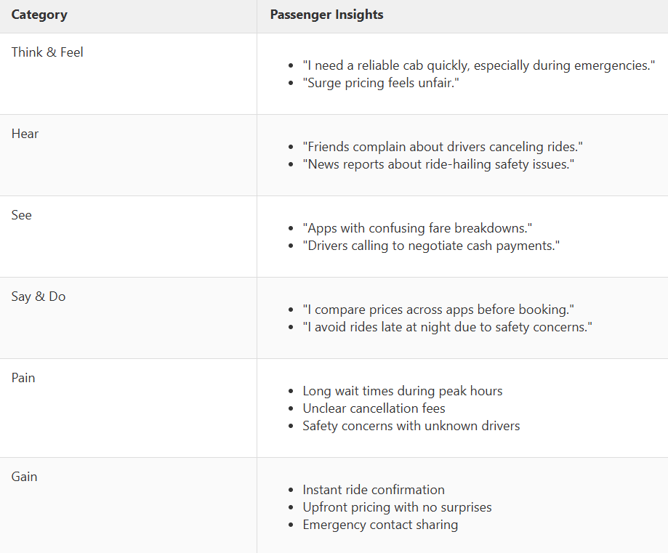

Driver Empathy Map
